KENTISBURY AND TRENTISHOE PARISH COUNCIL.
KTPC.ONLINE
TO ALL COUNCILLORS: You are summoned the Parish Council Village Hall at 7pm the 7th July 2025
Councillors present: (Chair) Dunn, Mathers, Isaac, Harper Davis, Waller, Pile.
Also present Clerk: D Bleasdale, C Cllr Davis

1/7/25 Public Participation: None
2/7/25 Apologies Absence: Cllr Walley, PC Elliot.
3/7/25 Declarations of Interest. Cllr Waller, Cllr Dunn, Cllr Pile regarding 80178
4/7/25 Approval of the Minutes for the 2nd June 2025 Accepted as a correct representation of the meeting. Proposer Cllr Harper Davis, seconded by Cllr Mather, decision unanimous.
5/7/25 Matters Arising from the minutes: Cllr Dunn sent a letter regarding planning enforcement, this was sent to the other Cllrs via the Clerk.
6/7/25 Police Report: No Report.

7/7/25 County Councillor Mrs A Davis: C Cllr Davis, please see full report at the end of minutes.
8/7/25 District Councillors M Prowse: Not Present.
9/7/25 Clerk’s actions from the last meeting not mentioned elsewhere on the Agenda: I have begun reviewing the existing policies that Parish Council has, so far it doesn’t look like any changes are needed. I hope to finish painting the war memorial this weekend. I attended the Code of Conduct Training Course ran by Simon Fuller the monitoring officer.

10/7/25 Planning to consider. 62/62/25/002 Lawful development certificate for the existing use or development (CLEUD) to establish that the continued occupation of the annex in breach of the conditions is lawful and therefore immune from enforcement action at The Cottage, Trentishoe Coombe, Road From Trentishoe Down to Trenti, Trentishoe, Devon, EX31 4QB. Approval proposed by Councillor Dunn Seconded by Councillor Mather, decision unanimous.
80178 Conversion of redundant building to dwelling and associated work at Barn South of Beaufort Kentisbury Barnstaple Devon EX31 4NT. Refusal proposed by Councillor Dunn Seconded by Councillor Waller, decision unanimous. Very poor accessibility for vehicles. Additional road movement. Poor entrance visibility. No local need. Development in the open countryside. Treated as an exception site under the local plan.
80492 Part retrospective change of use to B8 open-air storage and associated grading and landscaping works at Land at Porte Farm Kentisbury Barnstaple EX31 4NL. The Parish Council would like to the decisions to be made in line with local planning policy

11/7/25 Planning Decisions: None

12/7/25 Finance Balances will be tabled.
Treasurers account £8,927.98
Business Bank Account £3,187.28

13/7/25 To approve the following payments:
12 hours payment for parish Clerk plus £9.60 travel allowance.
Georgie Edgington £170
Proposed by Cllr Isaac seconded by Cllr Waller, agreed unanimously.
14/7/25 Items raised by the Councillors/Clerk: The Clerk will paint the war memorial and have it pressure washed, and shall contact Pete Starbuck regarding cutting the triangle of grass near the war memorial. Cllr Dunn reported that a chip van will be at the village hall between 5pm and 8pm on the 26th August, people can eat in the village hall or take them away. Grey Lippley is the new chair of the Village hall committee. The idea of an agreement regarding traffic management around the school and a possible one way system was discussed. Cllr Davis will look into getting the Mary Jones Trust accessible with additional signatories.
15/7/25 To agree a date of the next meeting. If planning is received a meeting will take place on the 4th August.
Part 2 Confidential Matters.
None
Meeting closed 20:00

Kentisbury and Trentishoe Parish Council
County Councillors Report
July 2025
20 is Plenty update
I wanted to give you a heads-up on the latest regarding 20mph speed limit areas across Devon.
The Cabinet Member for Climate Change and Biodiversity recently sent an email to some council members, outlining what looks like a new policy. It seems Parish Councils might be asked to contribute a significant amount of money to implement 20mph zones. For smaller, more rural parishes, or those in areas with higher deprivation, this could be a really substantial sum. This potentially puts these communities at a disadvantage, which is definitely a concern.
However, this is just an early indication of the emerging policy. We'll have much more concrete information after the Cabinet meeting in July, where a final decision will be made. I'll be sure to update you as soon as we know the outcome.
I'll likely be in touch before our next meeting, and I'll be happy to share all the details then.
From: Councillor Jacqi Hodgson <jacqi.hodgson@devon.gov.uk>
Sent: 16 June 2025 16:57
Subject: RE: 20 is plenty
Dear All,
The blanket approach will ensure that all cities, towns and parishes within DCC will be able to choose to have 20 mph speed limits in their local areas that fit with the ‘20’s plenty’ provision “where people live, work, play and go to school”. To date those who have requested this have needed to define the areas / streets they wished to have designed at this reduced speed, fit into a scoring system that would benefit from fatalities and be awarded minus points for have a zebra crossing (!!). Then, just a few areas per year would go forward with officer support.
My hopes for this new blanket policy would still be to still require City, Town and Parish Councils to approve a proposal with a map of the streets for 20’s Plenty and be prepared to contribute to the costs. I would also seek DCC officer support in terms of any safety audits, mapping, legal support etc that is already in house at DCC. The costs are anticipated at ~£25,000 per parish, although I’m guessing that will vary according to the amount of road to be changed to the lower speed. Where local councils are passing the 20’s plenty motion in their council meetings, these potential costs up to £25,000 should also be taken into account and they would need to be prepared to raise their part of the precept perhaps over 1-2 years in order to raise these funds. In a smaller parish of say 300 households, this would amount to a rise of around £83 per household if sought in one year, or £41.50 if spread over 2 years. I.e., less than £2 or £1 per week to cover the start up costs.

Since the introduction of 20’s Plenty in Wales there has been a recorded 28% reduction in fatalities. In my view, £1 - £2 per week over a couple of years is not a high cost for this level of safety, and is probably a lot less than some people pay for life insurance.
My conversations on doorsteps have indicated that many people would be more than willing to pay more council tax for improved council services including lower speed limits to make local streets safer and more pleasant to use.
As you will be aware, this new policy is currently being developed at DCC and is expected to come back to Council in July for a recommendation that will go to Full Council in September.
Hope this helps.
Kind regards,
Cllr Jacqi Hodgson
Devon County Councillor for Totnes & Dartington
Green Party representative
Exmoor Coaster
If you fancy a day out….£3!
This year the route is heavily subsidised by the local authorities especially Devon County Council, please make every effort to promote it.
Until 23 July
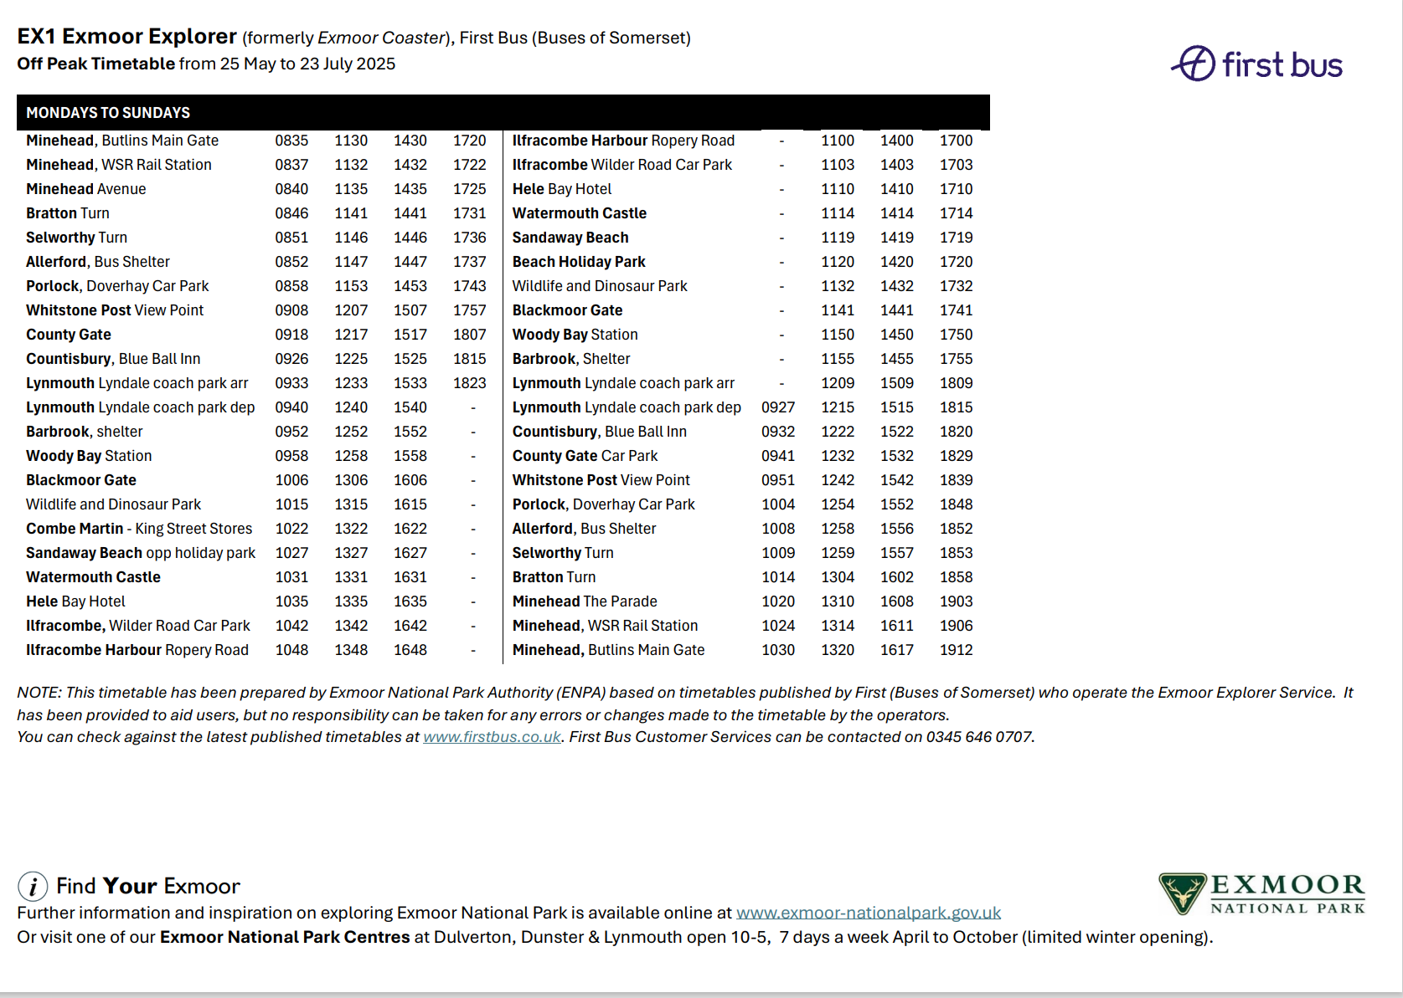

From 24th July to 31st August

Summer Holiday Activities and Food (HAF) programme.
The Government-funded scheme provides activities and nutritional meals over the holidays for children aged five to 16 who receive benefits-related free school meals.
If your child is not eligible for benefits-related free school meals they still may be able to access activities under the ‘extended criteria.’
More information about the extended criteria on information for parents and carers on our children, families and education webpage.
It is now possible to book activities online. The new EEQU system displays all the holiday activities on offer, with links detailing where and when the activity is, how to get there and other important information. Once you’ve applied the booking system will carry out an instant assessment of their eligibility to attend. If eligible, you will receive a confirmation of the booking and you will be sent reminders ahead of the session.
If you need to cancel its easy to do and will free up the slot allowing those on the waiting list the chance to book.
There are over 100 holiday activity providers around Devon who provide a wide range of activities for children and young people.
From arts and crafts workshops to sports and outdoor activities, the programme is designed to keep children engaged, active, and well-nourished during the school break. All clubs will be operating for a minimum of four hours and will include a hot meal.
One of the venues available is the Calvert Trust which offers a range of activities and is a great opportunity to try something new.
Refurbished White Goods
A new workshop dedicated to refurbishing large domestic appliances for resale across Devon has now opened.
SUEZ Recycling and Recovery UK Ltd, who operate 18 Household Waste Recycling Centres (HWRCs), has opened their new reuse hub in North Devon.
Skilled technicians will thoroughly clean and refurbish a wide range of white goods such as refrigerators, freezers and washing machines which will then be distributed to reuse shops in our Household Waste Recycling Centres (HWRCs) across the county for resale.
The refurbished items will be safety and function tested to ensure they meet safety and quality standards.
Depending on availability, the refurbished appliances are now being sold at Devon Reuse Shops in the following HWRCs: Bideford, Brunel Road in Newton Abbot, Marsh Barton Exeter, Ivybridge, Knowle Hill in Exmouth, Pinbrook Road in Exeter, Sidmouth, and Seven Brethren in Barnstaple.
Each appliance will each have a 30-day money back guarantee.
Initially set up in September 2023 to safety test small electrical items such as radios, televisions, and electric lamps for resale, the hub then began refurbishing bikes.
The expansion of the reuse hub follows a major recycling milestone being reached. As of last autumn, more than 10,000 tonnes of discarded everyday items, such as bikes, televisions, and furniture, have been diverted for reuse since 2012 thanks to our recycling centres.

The DCC website is very useful for reporting highway problems and the reports go straight to the contractor. Report a problem - Roads and transport
Alternatively, the highway contact number is 0345 155 1004
If it’s a river flooding the environment agency can be contacted on 0345 988 1188
Winter road updates; https://www.devon.gov.uk/roads-and-transport/safe-travel/winter-travel/
Travel Devon website; home - Travel Devon

Andrea Davis
County Councillor
Combe Martin Rural Division
Andrea.davis@devon.gov.uk

